François Mindiel

ID 2804582

Web scripting

Online Auto Trader

Table of Contents

1. Executive summary 2

2. Proposal 2

3. Online Auto Trading Website 2

4. Testing of the website 6

5. Conclusion 6

Figure 1: Homepage 2

Figure 2: seller's page 3

Figure 3: adding a car 3

Figure 4: seller's listed cars 4

Figure 5: seller login 4

Figure 6: seller registration form 5

Figure 7: invalid password length 5

Figure 8: onlineautotrader database 6

# Executive summary

This assignment is to demonstrate our understanding of web scripting, through the design of a website, using different languages, such HTML, CSS, javascript, php and SQL.

# Proposal

This project is about designing a website for an online vehicle trading business. It is comprised of a client-side and server-side website. The website enables registered users to advertise their cars online, and thus be viewed by anyone looking for a car.

# Online Auto Trading Website

The website’s homepage lists the different options available to the user, such as seeing the cars listed in the database, login in as a registered seller and searching for cars, with specific information. It is quite a simple website, but has the bare necessities to fulfil the tasks required for such a task.

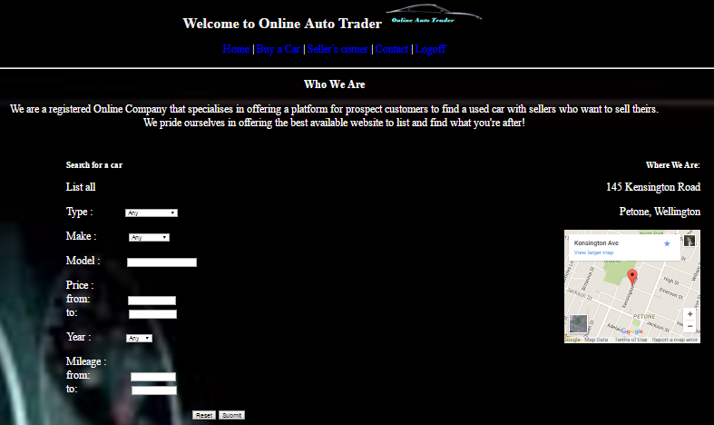

Figure 1: Homepage

When logging in as a seller, the user can either add a car to the database, or view his previously added cars. When viewing the cars, the user has the option to delete the cars he has in the database. A message will ask the user to confirm the deletion, to prevent accidental deletion, as it will be lost forever.



Figure 2: seller's page

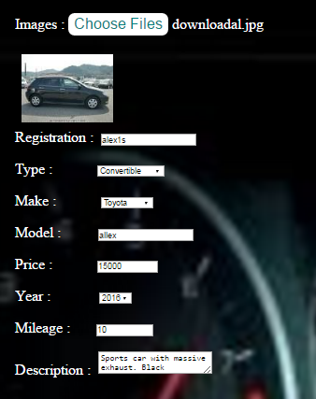

Figure 3: adding a car

When adding a car, the user can add a picture, and the above details. Some javascript are used to validate the input. For example, the registration has to be 6 characters long (as per NZ laws), price cannot be more than $1000000, and mileage cannot be more than 500000km. If there are any errors, the system will display an error message.

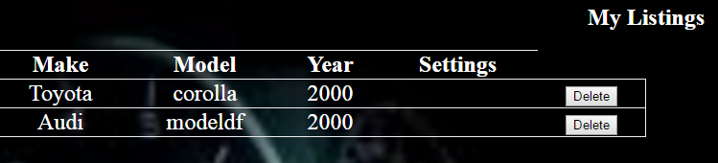

Figure 4: seller's listed cars

If a user is not already registered, he has the option of doing so. If the user doesn’t register and log in, he can only view cars on sale, but not sell his.

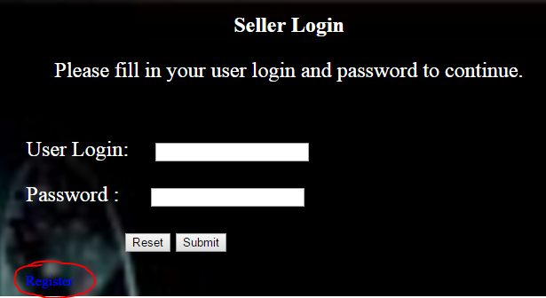

Figure 5: seller login

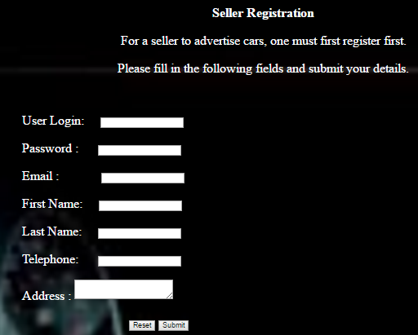

Figure 6: seller registration form

From figure 5, when a user wants to register, he is asked for the above details. The user login is unique for the users; meaning that 2 users cannot have the same user login. Also, there are javascripts in place to ensure that the user details are valid. For example, the password has to be a minimum length of 8 characters, the email field needs to have ‘@’ and end up with ‘.com’, ‘.co.nz’ or ‘.net’, and the phone number be 9 digits long (for home line phone numbers). If any field returns an invalid status, the system will display an error message, and give the user to fix the error(s) before submitting to the server.

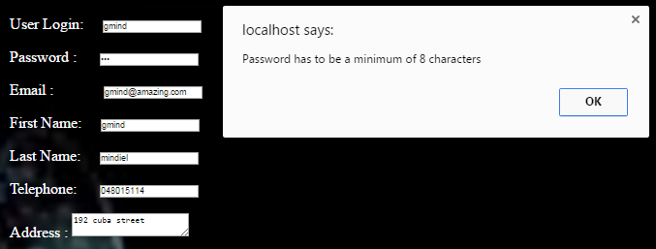

Figure 7: invalid password length

The server is comprised of a database called ‘onlineautotrader’ which has 4 tables to store the data on the server.

The ‘users’ table is used to store the registered sellers in the system, with their login as the unique and primary field.

The ‘vehicles’ table stores the information of different vehicles, and is linked to the ‘users’ table.

The ‘images’ stores a picture for a car, and is linked to the ‘vehicles’ table.

The ‘feedback’ stores feedbacks on sellers.

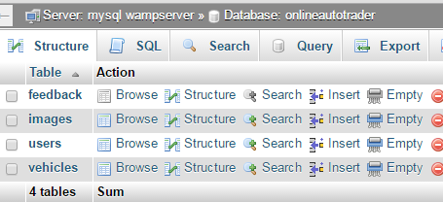

Figure 8: onlineautotrader database

# Testing of the website

Testing of the website was done by ensuring that it responded appropriately. Unfortunately, there are still some errors occurring, notably when it comes to the sellers’ feedback. Also some amendments were done, and initial information, such as the ‘contact’ page got lost. All in all however, the website demonstrates that it can perform quite well, and meets the basic requirements of the project.

# Conclusion

Through these 4 months, this project has enabled me to demonstrate what has been taught to me. Although such website is quite rudimentary compared to other websites (such as trademe), it shows the understanding grasped when it comes to website scripting.